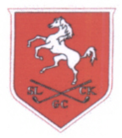
SLCKGC

25th SEPTEMBER 2017
AUTUMN MEETING – REDLIBBETS GC

The winners of the Autumn Salvers were Helen Albery and
Christine Mears, Faversham GC with 41 points on c/b
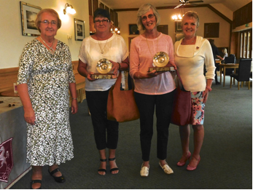

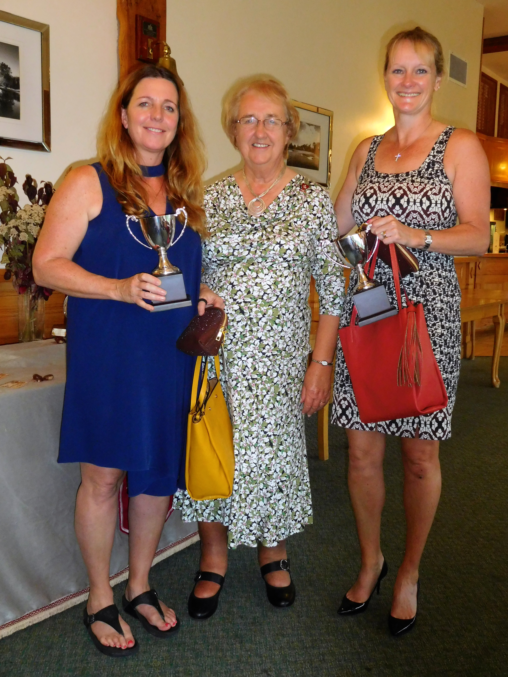
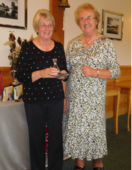
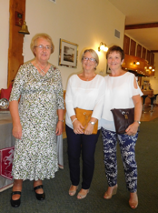
Runners Up and | Club | Points
Winners of the Autumn Cups
Adele Young and Carol Turl | Nizels GC | 41 points on countback
Third Place
Barbara Carpenter & Josi Moseley. | Redlibbets GC | 41 points on countback
Fourth Place
Valerie Harrison & Jan Sayle | Faversham. | 39 points
Front 9
Margaret White & Jeanie Ash | Cherry Lodge | 20 points.
Back 9
Patricia Moscow & Jean Dougal | Wildernesse. | 19 points

Nearest the pin on 4 holes: 6th Barbara Carpenter – Redlibbets, 8th Penny Perkins - Chestfield. 13th Susan Simpson with a Hole in One. 17th Anne Laming - Chart Hills.
Nearest the Line: Anne Lake - Canterbury
Congratulations to Sue Simpson on her Hole in One, SLCKGC presented her with a gift.

